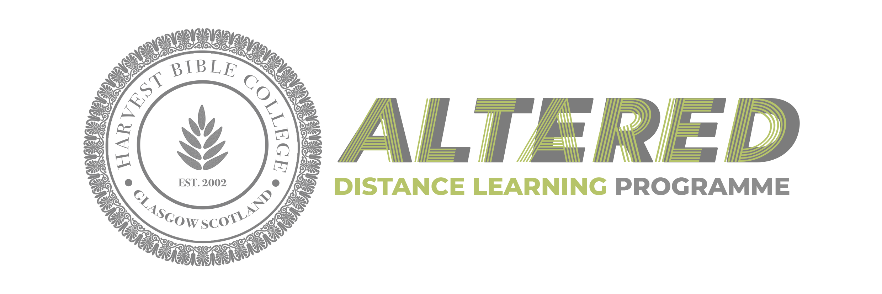

**APPLICATION CHECKLIST**

* Pastor’s approval for attendance
* 2 passport size photographs
* £50.00 non-refundable application fee
* Certified copies of educational qualifications
* Signed application w/pastor’s signature
* Send required documents by email to hbcgbi@aol.com